**Project-Phase II: Decision Making**

Laukik Pathak(1226939222)

Omkar Patel(1226466724)

Abhinav Kumar(1226878213)

Rafe Mohammed Abdul(1226360735)

Masters in Information Technology, Arizona State University

IFT 598 Topic: Data Visualization & Reporting for IT

Prof: Asmaa Elbadrawy

November 20, 2022

**Section 1: Used Visualization Tools**

Given that the dataset we've chosen has fewer rows and columns than most. The visualizations will be made in Tableau, and then the dashboard will be merged with the individual visualizations.

When there are fewer rows and columns in the data, Tableau excels. It allows us to quickly build visualizations using its drag-and-drop interface. Tableau will also provide easy-to-use characteristics for modifying the visualization and giving it a new form.

**Section 2: Explanation of Required Data Pre-processing**

In case your data requires any kind of pre-processing such as computing certain attributes or removing missing values, explain how the data will be processed and prepared for visualization.

We need to preprocess our database as this has some redundant values.

1. Since the dataset is not related to any traffic crimes the column IS_TRAFFIC is having 0 throughout the dataset. This is redundant attribute and would not help us in getting any information. So, we decided to remove it from the dataset.
2. IS_CRIME attribute of the dataset is used to indicate whether the data point is a crime or not. All the rows of this attribute are 1 indicating that all of them are in fact a crime. This attribute also doesn’t give us any new information and is redundant. Hence, we have decided to remove it.
3. The LAST_OCCURANCE attribute has a lot of missing values. In total more than 50% of the rows in the dataset has these values missing. Hence, we have decided to remove the whole attribute.

**Section 3: List of Final Sets of Questions**

1. What is the trend of Crime over the year and average crime rate ?
2. What is the geographical location of different offence type? With an option to filter the data based on offence type.
3. What are the number of victims affected due to the crime in a location?
4. Which is the Top 5 Crime Category in Denver ?
5. What is the average of crimes in all districts? and which districts have crimes more than the average?
6. Which districts have less crimes than average of all districts? What are the maximum, minimum values of crime for all districts?
7. Top 5 Crime affected neighborhood
8. What is the trend in different crime categories?
9. Categorize the districts into three categories namely safest, safe and not safe.
10. What are number of occurrences of each offense type in different districts.
11. What is the total victim count per offence type?

**Section 4: Dashboard Plots**

1. This line chart represents monthly crime rate over a year and the average crime rate. The Preattentive attributes used here are 2D position and shape(circles to represent monthly rate).

1. The below scatter plot depicts the geographical location of offence type in different locations with a filter to change the offence type. The Preattentive attributes used here are shape(circles to depict offence type) & color(to depict different offence types).

1. The below Scatter plot represents the number of victims affected based on the geographical location and a parameter, calculated field to filter out the number of victims affected in a location. The Preattentive attributes used here are shape(circles), sizes (size of circles based on victim count) and Color.

Calculated field for victim count

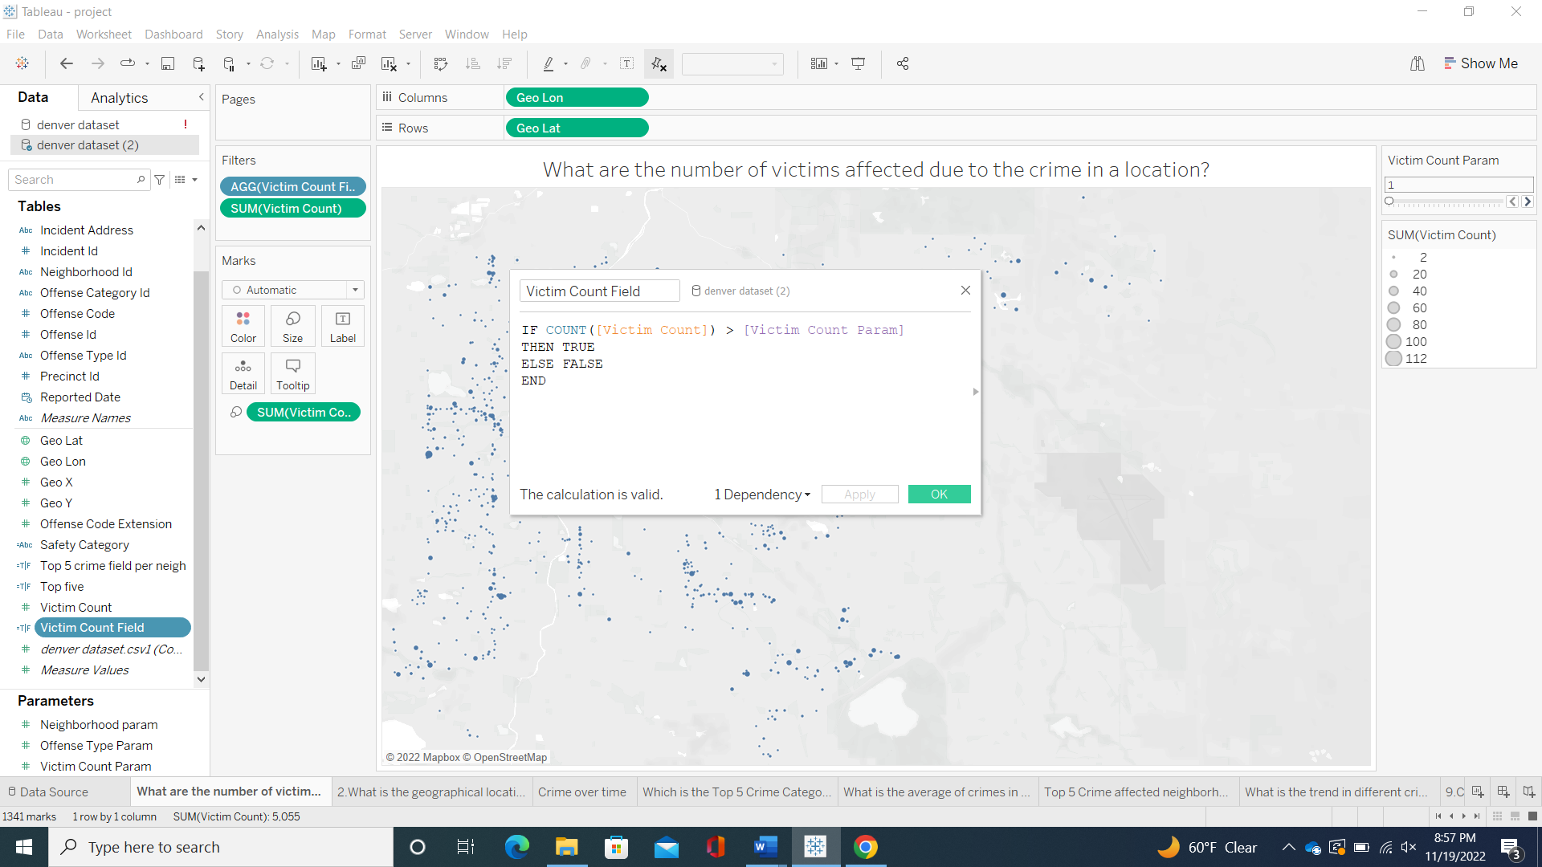

Victim Count Parameter

1. The below bar chart represents top 5 crime category in Denver. The top 5 crime category are filtered by the calculated field, parameter fields. The Preattentive attributes used here are length(length of bars) and color(to represent top 5).

Calculated field for top 5 victim count.

Offence type parameter

1. The below bar chart represents the maximum, median, average and minimum number of crimes. The Preattentive attributes used here are length and color hue(to represent median range).

1. The below bar chart represents the maximum, median, average and minimum number of crimes. The Preattentive attributes used here are length and color hue(to represent median range).

1. The below bar chart depicts the top 5 crime affected neighborhoods along with a neighborhood parameter, calculated field to filter out the top 5 neighborhoods. The Preattentive attributes used here are length and color(to represent top 5).

Calculated field for top 5 crime affected neighborhood.

Parameter for neighborhood.

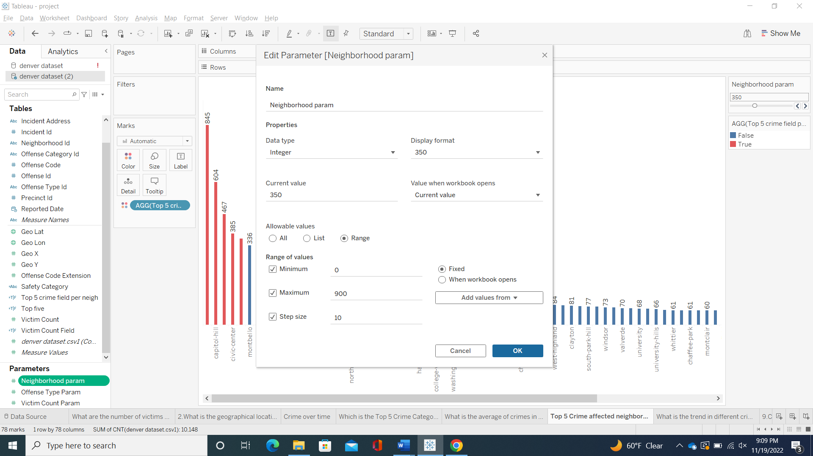

1. What is the trend in different crime categories?

1. Categorize the districts into three categories namely safest, safe and not safe.

Calculated field for safety category

1. What are number of occurrences of each offense type in different districts.

1. What is the total victim count per offence type?

**Section 5: Dashboard Interactivity**

* + - 1. The user can change the offence type id to get the geographical location of different offences that occurred accordingly (question 2).
      2. The user has a slider option to change victim count to get the geographical location of the victims affected by the crime (for question 3).
      3. The user can filter the top 5 crime categories using a slider( for question 4).
      4. The user can filter the top 5 crime affected neighborhoods using a slider(for question 7).

**References**

<https://app.mural.co/t/student6216/m/student6216/1668027483965/99fbbcbd1b339d6820dfd5744026486f11120c96?sender=u7d5c822e573b3c3158e81389>